**IMAGE AND VIDEO TO TEXT EXTRACTOR USING OPENCV AND EASYOCR**

This project is automatic number plate text extractor is based upon image processing and deep learning in data science domain. which is currently high demand technology in present time.

Working:

It takes input through camera in form of image and video to compare feed with machine learning models where we already have lot of trained data and do image processing and deep learning to generate output.

Hardware needed:

1. Full HD camera
2. GPU and CPU for processing
3. screen
4. storage device

Input:

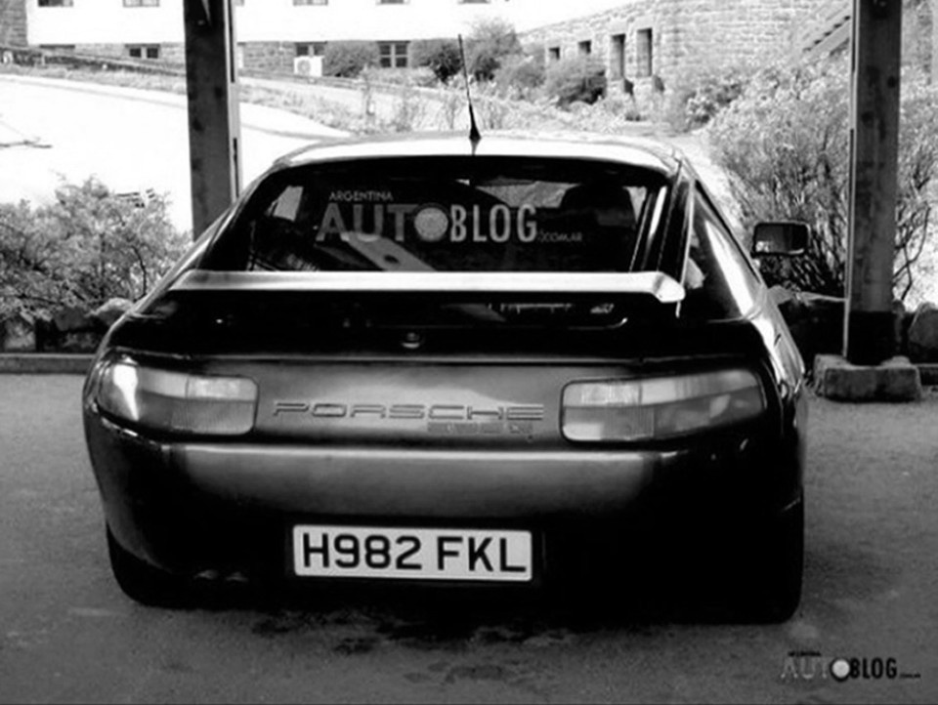

Output:

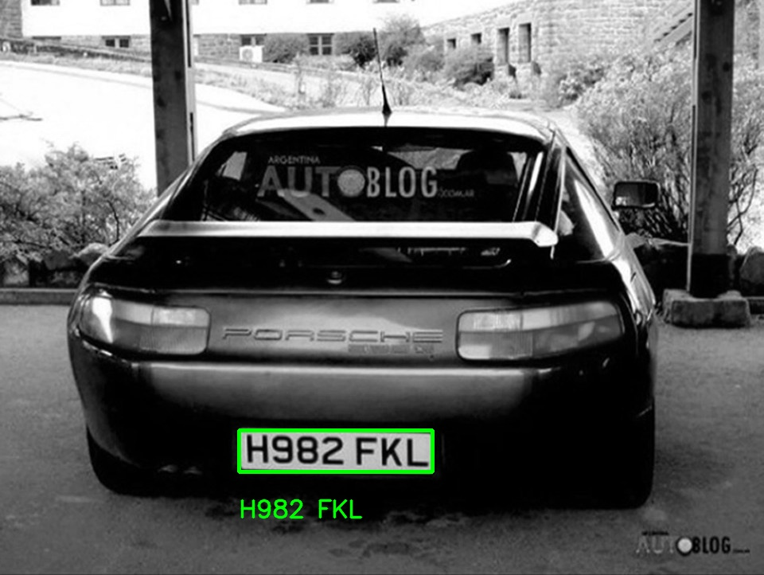

Advantage:

1. Automation
2. Accuracy
3. Cost-Efficiency
4. Environmental benefits
5. Security  
     
   Applications:

* [Weighbridges](https://www.cronj.com/weighbridge/unmanned-weighbridge-system.html)
* [City surveillance](https://www.cronj.com/blog/ai-in-security-is-giving-8-solid-city-surveillance-solutions-learn-more/)
* Sports venues
* [Border control](https://www.cronj.com/blog/ai-technology-is-tightening-border-security-learn-how/)
* Retail parks
* Low emission zones and in many other sectors.